Profile of the Faculty

**Name: PROF. ASHOK VITTHALRAO JADHAV**

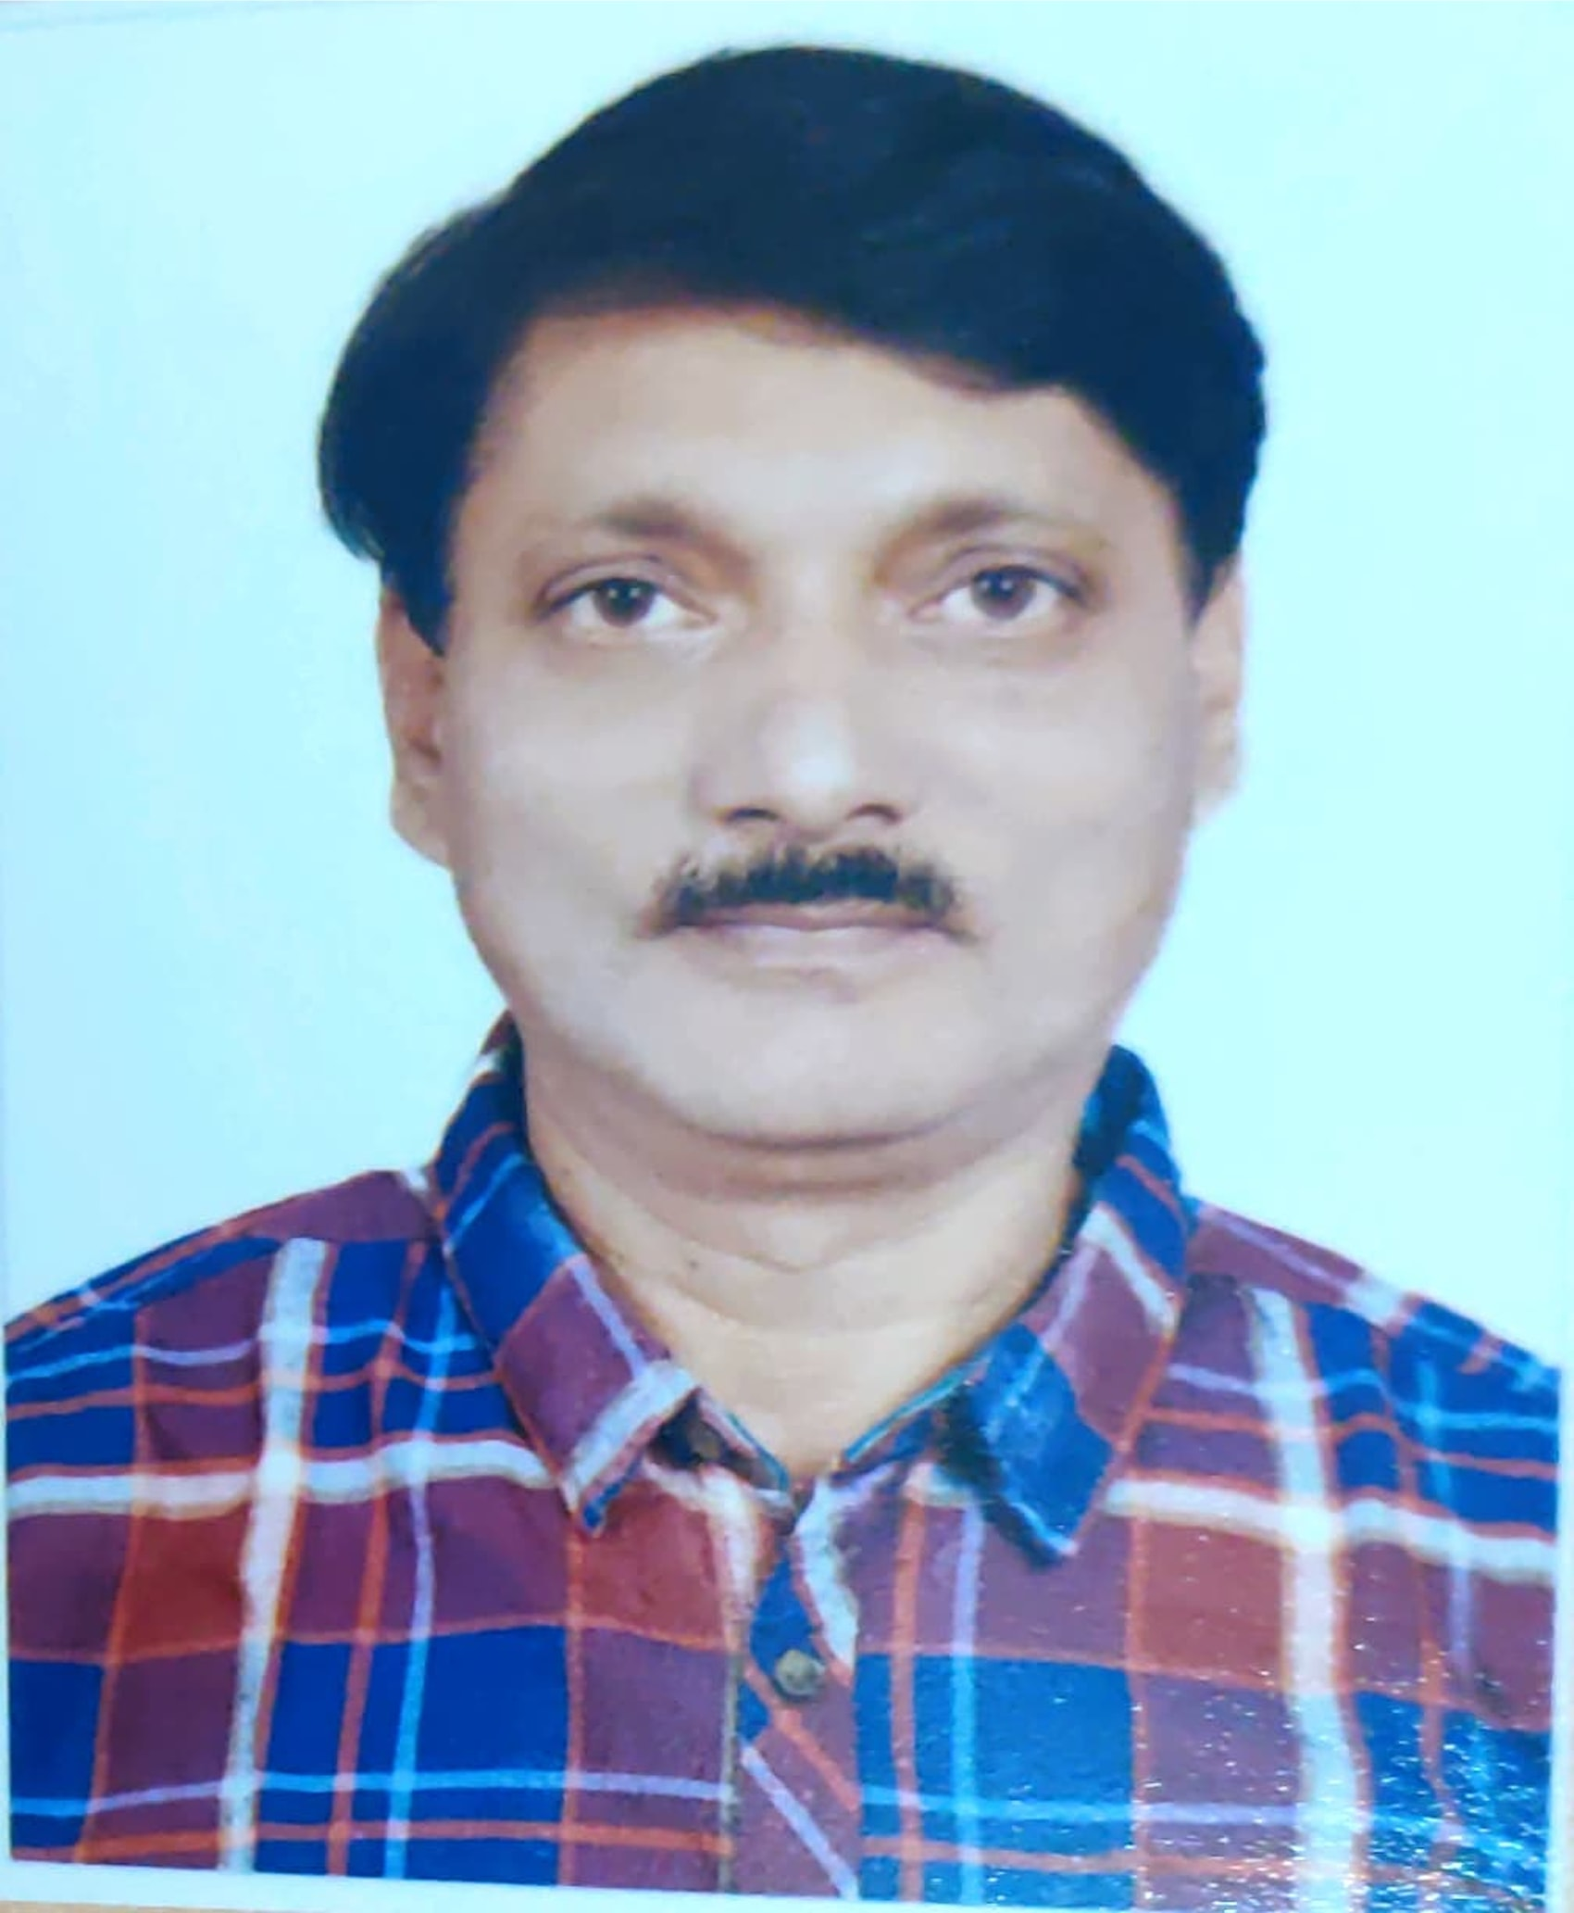

1. **General Information:**

|  |  |  |
| --- | --- | --- |
| Name of the Faculty | : | **SCIENCE** |
| Name of the Department | : | **CHEMISTRY** |
| Educational Qualifications | : | M.Sc. D.H.E. M.A. |
| Present Position | : | ASSOCIATE PROFFESOR |
| Date of Birth | : | 15/04/1964 |
| Marital status | : | Married |
| Address for Correspondence | : | JSM COLLEGE, ALIBAG DIST- RAIGAD |
| E-mail | : | ashokvjadhav@gmail.com |
| Contact Number | : | 7721813636 |
| Specialization | : | INORGANIC CHEMISTRY |
| Total teaching experience | : | 37 YEARS |
| Courses taught | : | B.Sc. , M.Sc. CHEMISTRY |

1. **Academic Qualifications:**

|  |  |  |  |
| --- | --- | --- | --- |
| Examinations | Name of the Board/University | Marks /CLASS | Year of Passing |
| S.S.C. (X th ) | MAHARASHTRA STATE  PUNE DIVISION | 69% FIRST | 1978 |
| H.S.C (XII th ) Science | MAHARASHTRA STATE | 52.5% SECOND | 1980 |
| B.Sc. (CHEMISTRY ) | SHIVAJI UNIVERSITY | 65.4% FIRST | 1983 |
| M.Sc. (CHEMISTRY;INORGANIC ) | SHIVAJI UNIVERSITY | 66.4% FIRST | 1985 |
| D.H.E. | MUMBAI UNIVERSITY | 66.4% FIRST | 1987 |
| M.A. (HISTORY) | SHIVAJI UNIVERSITY | 62.8% FIRST | 1991 |
| MS-CIT | MAHARASHTRA STATE BOARD OF TECHNICAL EDUCATION ,MUMBAI | 88% FIRST | 2005 |

1. **Record of academic service :**

|  |  |  |  |  |
| --- | --- | --- | --- | --- |
| **Designation** | **Nature of appointment** | **Name of Employer** | **Date of** | |
| **Joining** | **leaving** |
| **LECTURER** | TEMPERORY | JSM COLLEGE ALIBAG SR.COLLEGE | 23/11/1985 | 20 /04/1986 |
| **LECTURER** | TEMPERORY | JSM COLLEGE ALIBAG JR. COLLEGE | 01/07/1986 | 30/04/1987 |
| **LECTURER** | LECTURER | JSM COLLEGE ALIBAG SR.COLLEGE | 20/06/1987 | STILL WORKING TODAY |

* + Period of **teaching** **experience:** **P.G**. Classes (in years): **25 yrs.**

**U.G.** classes (in years): **37**  **yrs.**

1. **Academic Staff College Orientation/Refresher Academic development courses attended:**

|  |  |  |
| --- | --- | --- |
| **Name of the Course** | **ACADEMIC STAFF COLLEGE Place** | **Duration** |
| **Refresher** course in chemistry for college & university Lecturers | HIMACHAL PRADESH UNIVERSITY ,SHIMALA | 13/07/1992 TO 01/08/1992 |
| **Refresher** course Chemistry for college & University teachers | LUCKNOW UNIVERSITY,LUCKNOW | 01/01/1996 TO 27/01/1996 |
| **Refresher** course in chemistry | UNIVERSITY OF MUMBAI | 26/09/2003 TO 18/10/2003 |
| **ORIENTATION** programme | NORTH-EASTERN HILL UNIVERSITY ,SHILLONG | 11/02/2013 TO 10/03/2013 |
| **Certificate course in MS-CIT** | Maharashtra state Board of Technical Education ,Mumbai & on Govt of Maharashtra. | March 2005 |
| **Certificate of Achievement on NEW AGE TOOLS FORTEACHING ONLINE** | Academisthan | 20/06/2020 to 30/10/2020 |

**5 Participation in Conferences, Seminars, Workshops ,Symposium :**

|  |  |  |  |  |  |
| --- | --- | --- | --- | --- | --- |
| **Sr.**  **No.** | **YEAR** | **Title of Conference/ Seminar/Work shop etc.** | **Date of the event** | **Organized by** | **Whether International/ National/State/ Regional or**  **University level** |
| **1** | **1988** | Topics related to Environmental pollution at S.Y. &T.Y.B.Sc. Levels. | **01/03/1988 to 03/03/1988** | **University of Mumbai**  **Department of Chemistry**  **Mumbai** | **University** |
| **2.** | **1990** | One day workshop for college teachers on Ionizing radiations & Environment | **08/09/1990** | **Garware institute & University of Mumbai** | **University** |
| **3** | **1996** | National workshop on Radio Chemistry | **08/01/1996 to 30/01/1996** | **B.A.R.C. & IANCAS.& Lucknow University** | **National** |

|  |  |  |  |  |  |
| --- | --- | --- | --- | --- | --- |
| 4 | **1999** | Workshop in chemistry | 01/08/1999 | **BOS University of Mumbai & Vaze Kelkar college Mumbai** | **University** |
| **5** | **1999** | Workshop in Chemistry | 22/08/1999 | BOS in chemistry & University of Mumbai | **University** |
| **6** | **2003** | Workshop in Chemistry | 30/01/2003 | KMC college , Khopoli | **University** |
| **7** | **2003** | Workshop on Thermo analytical methods | 01/03/2003 to 03/03/2003 | Dept of chemistry & Institute of science,Mumbai | **University** |
| **8** | **2003** | Seminar in Chemistry | 05/03/2003 | ASC college Panvel | **University** |
| **9** | **2004** | Seminar on Laboratory Safety | 30/01/2004 | VPM college & BNB college & ITC Mumbai | **State** |
| **10** | **2005** | Symposium on Green chemistry | 29/03/2005 | Royal college & Indian association of chemistry | **National** |
| **11** | **2005** | Workshop on M.Sc. chemistry | 02/03/2005 | Dept of Chemistry ,University of Mumbai | **University** |
| **12** | **2005** | Workshop on Inorganic chemistry | 07/01/2005 | KMC college ,Khopoli | **University** |
| **13** | **2006** | Workshop on M.Sc.syllabus practicals | 19/08/2006 | University of Mumbai & BOS in chemistry & S.I.E.S. college Mumbai | **University** |
| **14** | **2007** | Workshop on sexual Harassment at work place | 13/01/2007 | WDC University of Mumbai & Paliwala college | **University** |
| **15** | **2008** | Camp/seminar on social work in society & Environment | 2008 | ASC college Panvel & Vivek Vahini Maharashtra | **State** |
| **16** | **2009** | Seminar on Marine Coastal Biodiversity & environment | 06/03/2009 | ASC college ,Phunde Uran,UGC sponsored | **State** |
| **17** | **2009** | Workshop on Election | 27/09/2009&04/10/2009 | ECI & Raigad Collector | **State** |
| **18** | **2010** | Workshop on Revised syllabus for T.Y.B.Sc.Inorganic  Chemistry | 26/06/2010 | University of Mumbai & BOS in chemistry & K.J.Somaiya college | **University** |
| **19** | **2010** | Workshop on Applied Components syllabus T.Y.B.Sc. | 28/10/2010 | University of Mumbai & BOS in chemistry & R.K.T. college | **University** |
| **20** | **2010** | Seminar on Environmental pollution& Monitoring | 17/09/2010  &18/09/2010 | UGC sponsor & CKT college Panvel | **National** |
| **21** | **2011** | Workshop on revised syllabus major Practicals | 28/04/2011&29/04/2011 | Dept. Of Chemistry ,JSM college ,Alibag. | **University** |
| **22** | **2011** | Conference on supra-molecular Chemistry& Nanomaterials | 14/02/2011 to 16/02/2011 | Dept of chemistry ,University of Mumbai | **International** |
| **23** | **2011** | Workshop on CBCS,semester,grade system | 23/03/2011&22/06/2011 | CKT college ,Panvel  Somaiya college ,Mumbai | **University** |
| **24** | **2011** | Workshop on CBCG system for F.Y./S.Y. | 18/08/2011 | J.S.M. College ,Alibag | **University** |
| **25** | **2012** | Camp/Workshop on Civil Defence | 07/05/2012 to 11/05/2012 | JSM college & State govt. Civil Defence | **University** |
| **26** | **2012** | Conference on New Horizons in Chemistry for the benefit of human race | 22/10/2012&23/10/2012 | University of Mumbai & Thakur college ,Kandivali Mumbai | **National** |
| **27** | **2013** | Symposium on New Vistas in chemistry | 28/09/2013 | Dept of Chemistry & Royal Society of Chemistry west India section & Wilson college | **National** |
| **28** | **2013** | Course on basic Computer Savvy | 21/10/2013 to 30/10/2013 | JSM college ,Alibag & CS,IT Dept of the college | **District** |
| **29** | **2016** | Workshop on Reversed Syllabus of T.Y.B.Sc. CBSGS | 05/03/2016 | KC college,Mumbai& BOS in chemistry University | **University** |
| **30** | **2017** | Conference on Modern Research Trends in chemistry & Allied Sciences. | 25/02/2017 | Dept of Chemistry & Allied sciences ,JSM College ,Alibag | **National** |
| **31** | **2017** | Workshop on revised syllabus for M.Sc. Part I (Sem I& Sem II) Chemistry | 04/10/2017 | BOS in Chemistry ,University of Mumbai & Paliwala college | **University** |
| **32** | **2018** | Workshop on Revised Syllabus for T.Y.B.Sc. Chemistry (Sem V &Sem VI) | 26/07/2018 | BOS in Chemistry ,University of Mumbai & Paliwala college | **University** |
| **33** | **2019** | International conference on chemistry | 08/03/2019 & 09/03/2019 | JSM college ,Alibag | **International** |
| **34** | **2020** | Awareness Program on corona Virus | 27/04/2020 | KES A.P. Science College ,Nagothane | **University** |
| **35** | **2020** | Conference on Application of Quantum Chemistry | 03/05/2020 | SPK Mahavidyalaya , Sawantwadi, Dept of chemistry | **National** |
| **36** | **2020** | Seminar on Advances in material Science | 20/05/2020 | Dept of chemistry,MD college Parel Mumbai | **National** |
| **37** | **2020** | Webinar on Covid 19 Pandemic from Chemistry’s Perspectives | 22/05/2020 | MPASC,college Panvel | **National** |
| **38** | **2020** | Challenges to Discovery of novel Drug | 31/07/2020 | Dapoli UBSSC ,college Dept. Of chemistry | **International** |
| **39** | **2020** | Patent & Patenting Process | 18/07/2020 | Dept of chemistry Pater & Varde college, (RUSA sponsored ) | **International** |
| **40** | **2020** | Basic Sciences : challenges & Opportunities | 13/07/2020 | Vikas college ,Vikhroli ,  Mumbai | **National** |
| **41** | **2020** | State of environment After covid-19 Lockdown | 13/06/2020 | Dept of chemistry Pater & Varde college, Mumbai | **National** |
| **42** | **2020** | Understanding Cosmetics | 30/05/2020 | HSNC University, Mumbai ,KC college Dept of chemistry. | **State** |
| **43** | **2021** | Conference on Recent Advances in chemical,physical & Biological sciences | 29/06/2021 & 30/06/2021 | ACT & Homi Bhaba center education,TIFR Katol college | **International** |
| **44** | **2021** | Career Prospects in Chemistry | 07/07/2021 | Dept of Chemistry & Maharashtra College ,Mumbai | **State** |
| **45** | **2021** | Nanotechnology Enabled energy conversion & storage technologies | 09/07/2021 | Physics Dept. JSM college , Alibag. | **Webinar** |
| **46** | **2021** | Rise for Better Living | 11/07/2021 | WDC University of Mumbai & MES’s College of Education Chembur | **Webinar** |
| **47** | **2021** | Workshop on Career advancement Scheme for college Teachers | 31/07/2021 | IQAC JSM college Alibag & University of Mumbai | **State** |
| **48** | **2021** | Workshop on CAS writing Skills of Literature & framing the objectives & Hypotheses | 07/10/2021 & 08/10/2021 | IQAC & Ghokhale Education Society college, Shreewardan | **National** |
| **49** | **2021** | Seminar on Investment Awareness Program-introduction to stock exchange | 05/10/2021 | KES,s A.P. Science College Nagothane | **National** |
| **50** | **2022** | Conference on Green chemistry for Sustainable Future | 21/01/2022 & 22/01/2022 | Dept of Chemistry ACS college ,Bhandara | **National** |
| **51** | **2022** | Seminar on Opportunities & Career in Pharmaceutical Industry | 29/01/2022 | Dept. Of Chemistry ,JSM College , Alibag. | **National** |
| **52** | **2022** | Conference on Wetland Action For People & Nature | 02/02/2022 | Society for clean environment & Ruparel college Mumbai & international centre for climate& sustainability action foundation | **International** |
| **53** | **2022** | Conference on Chemistry Education | 04/02/2022 & 05/02/2022 | Dept of chem , K.N. Mahavidyalaya,Nagpur & Madhav College Ujjain & ACT Mumbai | **International** |
| **54** | **2022** | Seminar on Introduction to Periodic table | 10/02/2022 | Dept of chemistry, JSM College ,Alibag. | **National** |
| **55** | **2022** | Workshop on Research Methodology | 12/02/2022 | Doshi Vakil college Goregaon Raigad & Rafiq Zakaria College Aurangabad | **International** |
| **56** | **2022** | Conference on Empowering Diversity in Science | 16/02/2022 | Dept of Chemistry K.N.Mahavidhyalaya Nagpur, ACT Mumbai & IUPAC, Global World Breakfast | **International** |
| **57** | **2022** | Seminar on occasion of Celebrating Science day | 28/02/2022 | Dept of chemistry & science association JSM college ,Alibag | **National** |
| **58** | **2022** | Seminar on Emerging Trends in Chemical Sciences. | 11/03/2022 | IQAC ,Dept of Chemistry Kokan Gyanpeeth College ,Karjat | **National** |
| **59** | **2022** | E-workshop on Quality Management system for administration -a NAAC perspectives | 15/03/2022 | IQAC, Bharat College ,Badlapur. | **National** |
| **60** | **2022** | Seminar on Practical Examination point of views | 24/03/2022 | Dept. Of Chemistry ,JSM college ,Alibag. | **college** |
| **61** | **2022** | Work ethics & Use of Digital Technology in Teaching | 13/07/2022 | IBS/ICFAI Business school , Mumbai.& JSM college ,Alibag. | **college** |
| **62** | **2022** | Quiz on Indian Freedom Struggle | 12/08/2022 | KJ Somaiya college of Science of Science & commerce & DLLE unit & Dept of Chemistry.Mumbai. | **College** |
| **63** | **2022** | Certificate of Appreciation for Pinning a flag | 15/08/2022 | Ministry of Culture , Government of India. | **National** |

**6.Contribution in the various committees at the college:**

|  |  |
| --- | --- |
| **Sr. No.** | **Name of the Committee-** |
| 1. | IQAC- quality assurance Cell college committee |
| 2. | Teacher Representative for College Development Committee from 25/07/2017 to 2022 |
| 3. | Chairman admission committee |
| 4. | Incharge science faculty |
| 5. | Unfair means committee |
| 6. | Cultural committee |
| 7. | Gymkhana committee |
| 8. | NSS committee |
| 9. | Discipline Committee |
| 10. | Career guidance Committee |
| 11. | Time table committee |
| 12. | Students facility committee |
| 13. | Co-ordination committee for the faculty of science |
| 14. | UGC- Quality Mandate Programme Committee- Evaluation reforms in HEI |
| 15. | Repair & maintenance committee |
| 16. | Office Administration /supervision committee |
| 17. | Youth festival Reception & Hospitality committee |

1. **Teaching contributions other than JSM college:**

*Invited & worked as Visiting faculty for M.Sc. Students of

1. CKT college ,Panvel.
2. Dr. Babasaheb Ambedkar college ,Mahad.
3. Dapoli Urban bank senior science college ,Dapoli.
4. Kelkar College,Devgad.
5. Mumbai University subcentre Ratnagiri
6. J.N. Paliwala college,Pali
7. S.R.M. college ,Kudal
8. SPKS college ,Sawantwadi.
9. **Contribution to University level:**
10. Worked as member of syllabus committee.
11. Worked as paper setter for UG and PG classes.
12. Worked as Evaluator for T.Y.B.Sc. Chemistry.
13. Worked as Subject experts for interviews of teachers on various colleges.
14. Worked as V.C. nominee & subject expert for CAS of teachers.
15. Worked as Moderators for T.Y. B.Sc. & M.Sc. Inorganic chemistry subject.
16. Worked as Practical examiner at various college centre of UG & PG classes.
17. Worked as member for Local Management Committee (LMC).
18. **Extra curricular activities:**
19. Giving guide lines forcompetitive exam to students.
20. Arranged & organized quiz for college students.
21. Participated in college arranged events.
22. Worked for NAAC , IQAC - criterion 5 & 6 .
23. Worked for Vaccination of COVID-19 & its Survey .
24. Interest in field of Reading ,Travelling , watching movies , sports & quality channels .
25. Sports like as Cricket, chess, table tennis.