Q.1 | Fill in the blanks : | [05]
1. | Area of Square=___________.
2. | The figure which exactly coincides with each other are called_________ figures.
3. | Rate of depreciation is always taken as __________.
4. | Cuboid has ____________ vertices.
5. | The perpendicular drawn from the centre of a circle to its chord __________ the chord.
Q.2 A) | Solve the following. | [10]
1. | If the radius of the circle is 28 cm, find the area.
2. | Find the amount if Principal = ₹ 2000 , Rate =5 p.c.p.a. and duration = 2 years.
3. | Write down Euler’s formula.
4. | If base of a parallelogram is 18 cm and its height is 11 cm, find its area.
5. | Write down the correspondence of ∆ XYZ and ∆DEF
B) | Solve the following | [15]
1. | In the following figures, parts bearing identical marks are congruent. State the test and correspondence of vertices by which triangles in each pair are congruent.  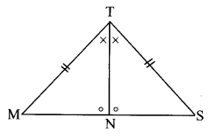
2. | Sameerrao has taken a loan of Rs 12500 at the rate of 12 p.c.p.a. for 3 years. If the interest is compounded annually then how many rupees should he pay to clear his loan?
3. | In the given figure, ☐ABCD is a trapezium, side AB || side DC, l(AB) = 13 cm, l(DC) = 9 cm, l(AD) = 8 cm, find the area ☐ABCD.  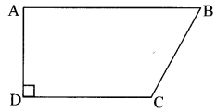
4. | Find the total surface area of a closed cylindrical drum if its diameter is 50 cm and height is 45 cm. (π = 3.14)
5. | In a circle with centre P, chord AB is drawn of length 13 cm, seg PQ ⊥ chord AB, then find l(QB)  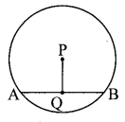
Q.3 | Solve the following (Any 5) | [20]
1. | In the following figure, parts shown by identical marks are congruent. State the test and the one-to-one correspondence of vertices by which triangles in each pair are congruent. Also state the remaining congruent parts.  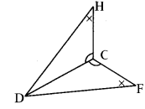
2. | A shepherd has 200 sheep with him. Find the number of sheep’s with him after 3 years if the increase in number of sheep’s is 8% every year.
3. | Look at the measures shown in the given figure and find the area of ☐PQRS.  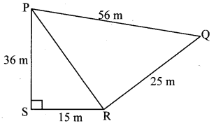
4. | For rain water harvesting a tank of length 10 m, breadth 6 m and depth 3 m is built. What is the capacity of the tank? How many litre of water can it hold?
5. | C is the centre of the circle whose radius is 10 cm. Find the distance of the chord from the centre if the length of the chord is 12 cm.  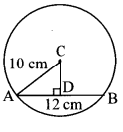
6. | Find the volume of the cylinder if the circumference of the base of cylinder is 132 cm and height is 25 cm.

